

MUT ICT Department Smart Web Application
FULL PROJECT DOCUMANTATION:
Internet Programming 2 (ITPR300 / ITNP300)
Assessment 2 – Full Stack Web Application Project

INITIALS AND SURNAME | STUDENT NUMBER
QC MTSHALI | 22364740
SS NGOBESE | 22335678
O LUTHULI | 22325286
NN NDIMANDE | 22330918
S NOMBIKA | 22312280

1. INTRODUCTION
The purpose of this project is to redesign and improve the current ICT Department website of Mangosuthu University of Technology into a modern, smart, interactive and data-driven full-stack web application.
The project was developed using HTML, CSS, JavaScript, Node.js, Express.js and a database system. The website provides students and visitors with important departmental information while also offering smart interactive features such as login authentication, chatbot assistance and dynamic data handling.
This system follows User Experience Design (UXD) principles to improve usability, navigation, responsiveness and accessibility.
ed using HTML, CSS, JavaScript, Node.js, Express.js and a database system. The website provides students and visitors with important departmental information while also offering smart interactive features such as login authentication, chatbot assistance and dynamic data handling.
This system follows User Experience Design (UXD) principles to improve usability, navigation, responsiveness and accessibility.

YouTube Link Video For My Group

https://youtu.be/v2SBhVOxwmE?si=FgaH8gaP1WhgRsd3

2. PROJECT OVERVIEW
Project Name
MUT ICT Smart Departmental Web Application
Project Type
Full Stack Web Application
Target Users
- Current Students
- Prospective Students
- Lecturers
- ICT Department Staff
- Website Administrators
- Visitors who want to obtain more information about ICT
Main Purpose
The purpose of the system is to:
- Provide departmental information online
- Improve communication between students and the department
- Offer smart and interactive website features
- Store and retrieve information dynamically from the database
- Improve user experience and website accessibility

3.Problem Statement
The current ICT Department website at Mangosuthu University of Technology does not fully meet the needs of modern students and visitors. Although the website provides basic departmental information, it lacks interactivity, smart features, and an engaging user experience. Many pages are static, making it difficult for users to interact with the system effectively. The overall design also appears outdated and does not fully support modern web standards and usability principles.
Another major problem is the lack of responsive design and accessibility features. Users accessing the website from mobile phones or tablets may experience layout issues, slow navigation, and poor readability. Since most students use mobile devices to access information, this negatively affects user satisfaction and accessibility. The navigation structure is also limited, making it difficult for users to quickly find important information such as admissions, courses, events, and departmental announcements.
The existing system also lacks backend functionality and dynamic database integration. Information is mostly displayed statically, with limited support for user authentication, data management, and CRUD operations. There is no secure login system for students or administrators, which limits personalization and secure access to protected content. Additionally, the absence of middleware and proper validation increases the risk of invalid user inputs and reduces system security.
The current website does not include intelligent or smart technologies that improve communication and engagement with users. Students often require quick assistance when searching for departmental information, but there is no chatbot or automated support system available. This creates delays in communication and reduces the efficiency of the website as an information platform.
Lastly, there is a need to redesign and redevelop the ICT Department website into a modern full-stack smart web application that improves user experience, responsiveness, security, accessibility, and interactivity. The proposed solution will integrate frontend and backend technologies, database connectivity, CRUD operations, middleware implementation, and AI-powered features to create a more efficient and user-friendly departmental platform.

4. PROJECT OBJECTIVES
The objectives of this project are:
- To redesign the ICT Department website using modern UX principles.
- To develop a responsive and interactive web application.
- To implement frontend and backend integration.
- To connect the system to a database.
- To implement CRUD operations.
- To implement middleware using Express.js.
- To integrate an AI-driven chatbot feature.
- To improve accessibility and navigation.
- To demonstrate understanding of HTTP methods and routing.
- To create a maintainable and scalable web application.

5. EXISTING WEBSITE WEAKNESSES

Existing problem | Improvement implemented
Static pages | Dynamic interactive pages
Poor responsiveness | Mobile responsive design
Weak navigation | Mobile responsive design
No log in system | User authentication system
No smart features | AI chatbot integration
Basic UI | Modern UI/UX design
Limited back end | Full Express backend
No CRUD operation | Complete CRUD functionality
No middleware | Middleware implementation
No limited feed back | Interactive feedback messages

6. PROPOSED SOLUTION
The proposed solution is a full-stack smart web application that:
- Uses Node.js and Express for backend development
- Uses HTML, CSS and JavaScript for frontend development
- Connects to a database for dynamic data storage
- Implements user authentication
- Provides CRUD functionality
- Includes an AI chatbot assistant
- Improves user experience through responsive design
- Uses middleware for validation and security

7. TECHNOLOGIES USED

Technology | Purpose
HTML5 | Structure of web pages
CSS3 | Styling and responsiveness
JavaScript | Interactivity and dynamic behaviour
Node.js | Backend runtime environment
Express.js | Web framework
SQL Database | Data storage
GitHub | Version control
VS Code | Development environment

8. SYSTEM FEATURES
Frontend Features
- Responsive homepage
- Navigation menu
- Admission page
- Courses page
- Careers page
- Events page
- Login page
- Profile page
- Welcome page
- Interactive forms
- Dynamic feedback messages

Backend Features
- Authentication system
- Route handling
- Validation middleware
- CRUD operations
- JSON data handling
- API endpoints

Smart Features
- AI chatbot assistant
- Intelligent responses
- User interaction support

9. FUNCTIONAL REQUIREMENTS
The system must:
- Allow users to access departmental information
- Allow users to log in securely
- Validate user input
- Store and retrieve data from the database
- Allow CRUD operations
- Respond to user requests dynamically
- Provide chatbot assistance
- Support mobile responsiveness

Use case diagrams.
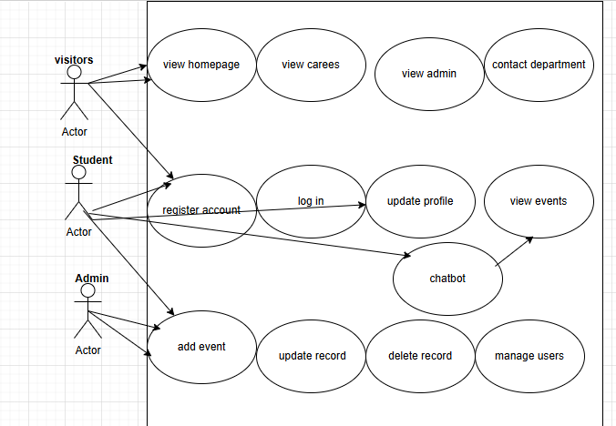

10.NON FUNCTION REQUIREMENTS

- The system must load pages quickly and respond efficiently to user requests.
- The website must be reliable and operate without frequent crashes or errors.
- The application must provide secure authentication and protect user information.
- Input validation must be implemented to prevent invalid or harmful data.
- The website must be responsive and work properly on mobile phones, tablets, and desktop computers.
- The system must be easy to use and provide simple navigation for all users.
- The interface must maintain consistent colours, layouts, and design elements.
- The application must be accessible and readable for different types of users.
- The system must be maintainable with organized and clean code structure.
- The website must be scalable to allow future updates and additional features.
- The system should support smooth interaction and good overall user experience.
- The application must provide stable backend and database connectivity.

11. SYSTEM ARCHITECTURE
Architecture Overview
The system follows a three-layer architecture:
1. Presentation Layer
Frontend developed using:
- HTML
- CSS
- JavaScript
2. Application Layer
Backend developed using:
- Node.js
- Express.js
3. Data Layer
Database used for:
- User information
- Authentication data
- Departmental information
Data Flow
- User sends request from browser.
- Request goes to the Express server.
- Middleware validates the request.
- Backend processes request.
- Database stores/retrieves data.
- Response sent back to frontend.

System architecture diagram.

Frontend

Node js. + express
Middle ware

database

Chatbot

12. DATABASE DESIGN
Main Database Tables
Users Table
Field | Type | Description
Id | INT | Primary key
username | VARCHAR | User surname
email | VARCHAR | User email
password | VARCHAR | User password

The Users table stores information about registered users of the system. It is mainly used for user authentication and login functionality. The table keeps user details such as username, email address, and password to allow secure access to personalized features.
Events Table
Field | Type | Description
Event id | INT | Primary key
title | VARCHAR | Event title
description | TEXT | Event description
date | DATE | date

The Events table stores information about departmental events and activities. It allows the system to manage and display event details such as the event title, description, and date for students and visitors to view.
Admissions Table
Field | Type | Description
Admission_id | INT | Primary key
Student_name | VARCHAR | Student name
course | VARCHAR | Course applied
status | VARCHAR | Admission status

The Admissions table stores student admission information. It helps manage applications by recording student names, selected courses, and admission status, allowing the system to track admission processes efficiently.

Database screenshot:

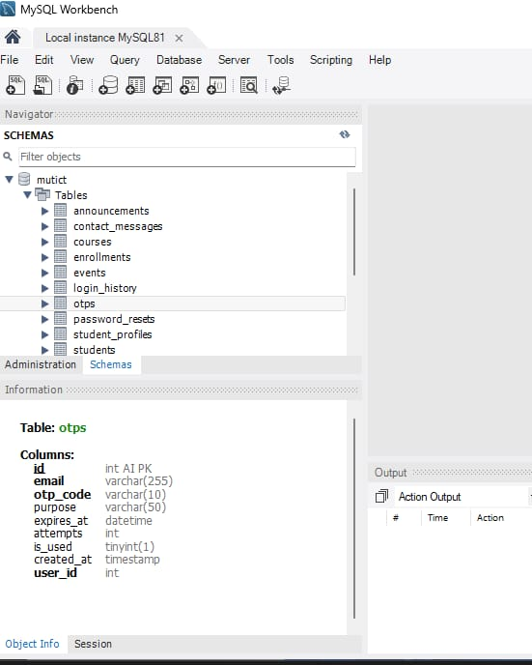

13. CRUD OPARATIONS
The system demonstrates all CRUD operations:
Operations | description
CREATE | Add new record
READ | Retrieve data
UPDATE | Modify existing data
DELETE | Remove records

Example of our CRUD Features:
- Create student accounts
- Read course information
- Update user profiles
- Delete outdated records

14. MIDDLEWARE IMPLEMENTATION
Middleware is implemented using Express.js.
Types of Middleware Used
Validation Middleware
Used to validate user inputs.
Authentication Middleware
Used to protect restricted routes.
Error Handling Middleware
Used to manage server errors.
Logging Middleware
Used to track requests and debugging.
Importance of Middleware
Middleware improves:
- Security
- Validation
- Error handling
- System organization

Middleware screenshot example:

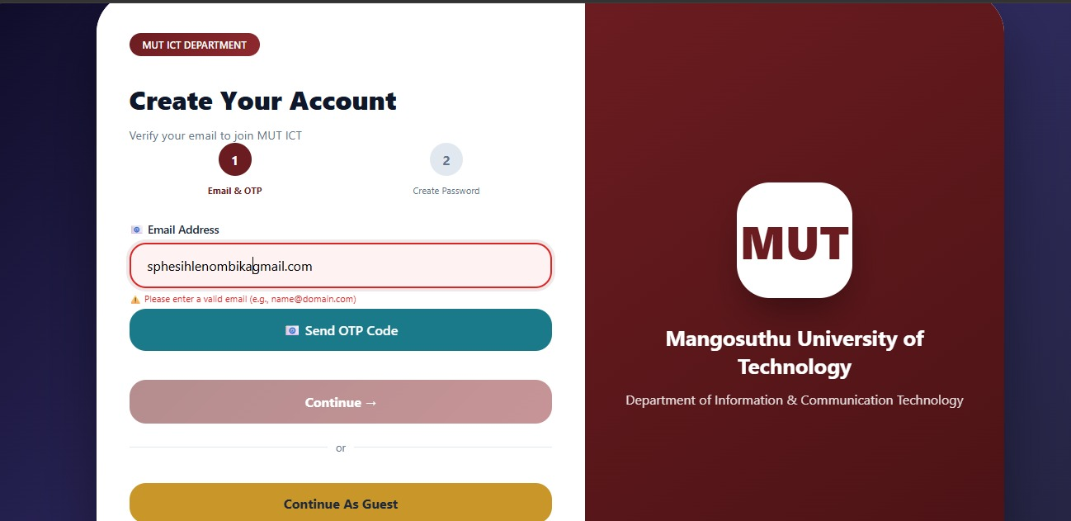

15. AI FEATURE IMPLEMENTATION
AI Chatbot Assistant
The system includes a chatbot assistant that helps users interact with the website.
Purpose of the Chatbot
- Answer basic student questions
- Assist users with navigation
- Improve user engagement
- Provide instant support
Benefits
- Faster communication
- Improved accessibility
- Better user experience
- Smart interaction system
16. FRONTEND DESIGN AND UX PRINCIPLES
The website follows User Experience Design (UXD) principles.
UX Improvements Implemented
Responsive Design
The website adapts to:
- Desktop screens
Improved Navigation
- Clear navigation bar
- Easy page access
- Organized content layout
Accessibility
- Readable typography
- Good colour contrast
- User-friendly interface
Consistency
- Consistent colours
- Consistent layout
- Uniform design elements
Feedback Messages
Users receive:
- Error messages
- Success messages
- Validation feedback

Chatbot sample:
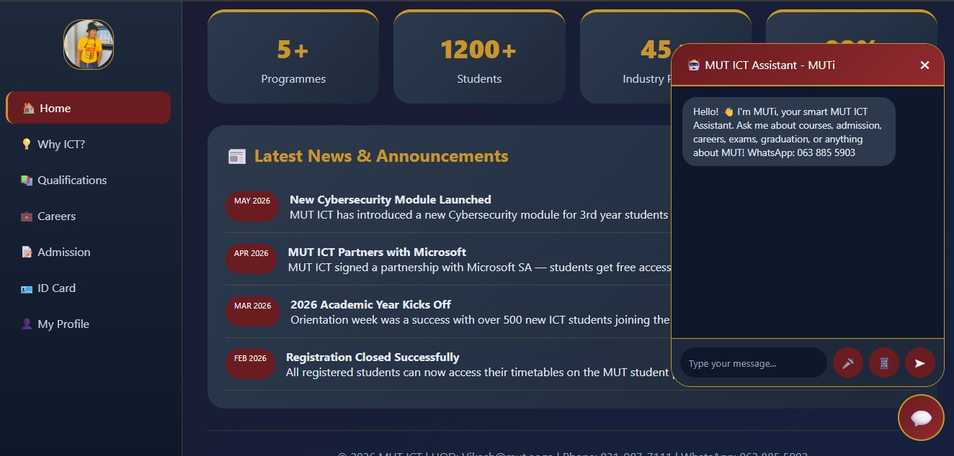

17. BACKEND DEVELOPMENT
The backend was developed using Node.js and Express.js.
Backend Responsibilities
- Route handling
- Request processing
- Response handling
- Authentication
- Data management
- Middleware execution

Main Backend files
Server.js
Main server configuration
Authcontroller.js
Handles authentication logic
Handles chatbot functionality
authRoutes.js
define chatbot routes
userModel.js
Handles user data operations

18. API ROUTES AND HTTP METHODS
GET Requests
Used to retrieve information.
Example: GET /profile
POST Requests
Used to create data.
Example: POST /login
PUT/PATCH Requests
Used to update existing data.
Example: PUT /update-profile
DELETE Requests
Used to remove data.
Example: DELETE /delete-user

19.File folder structure

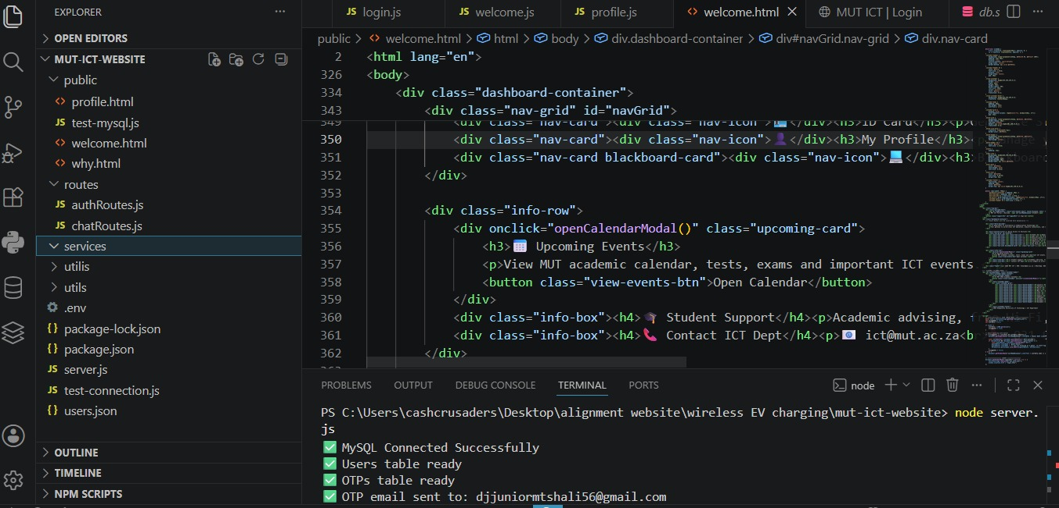

20.TEAM MEMBER CONTRIBUTIONS
Team members | contributions
QC Mtshali | Assisted with frontend design using HTML and CSS  • Helped create responsive web pages  • Worked on navigation and page layouts  • Assisted with project documentation
SS Ngobese | • Assisted with backend development using Node.js and Express.js  • Helped implement API routes and CRUD operations  • Worked on middleware and validation  • Assisted with testing and debugging
O Luthuli | • Assisted with database design and data handling  • Helped create database tables and relationships  • Worked on authentication and login functionality  • Assisted with system testing
NN Ndimande | Worked on frontend interactivity using JavaScript  • Assisted with chatbot integration and smart features  • Helped improve user experience and responsiveness  • Assisted with presentation preparation and documentation
S Nombika | • Assisted with research and project planning  • Helped gather system requirements  • Worked on documentation formatting and organization  • Assisted with testing and final project review

21. TESTING
Testing Conducted
Functional Testing
Checked whether features work correctly.
Responsive Testing
Form Validation Testing
Ensured invalid inputs are rejected.
Route Testing
Verified backend routes work correctly

22.Conclusion:

The MUT ICT Smart Departmental Web Application was successfully developed to improve the existing ICT Department website at Mangosuthu University of Technology. The project focused on creating a modern, responsive, and interactive full-stack web application that provides a better user experience for students, staff, and visitors.
The system successfully integrates frontend and backend technologies using HTML, CSS, JavaScript, Node.js, and Express.js. Database connectivity, CRUD operations, middleware implementation, authentication features, and an AI chatbot assistant were also included to meet the project requirements. The website was designed using UX principles to improve navigation, accessibility, responsiveness, and overall usability across different devices.
Through this project, practical knowledge and skills in full-stack web development, system design, backend integration, and user experience design were demonstrated. The final system provides a strong foundation for future improvements and smart digital services within the ICT Department. Overall, the project achieved its objectives and successfully addressed the problems identified in the existing website.

